**2.3 I can use a range of tools and techniques in the recommended way**

**Back Catalogue**

A back catalogue is a list of things/ tasks which need doing to succeed in a project. Initially a back catalogue may have only a few or generic tasks needed to complete, but it may subsequently change and evolve as requirements are satisfied or changed. Here is a copy of my back catalogue with a view to creating a website.

* Market research
* Produce requirements of project
* Produce website concept
* Wire diagrams of web pages
* Produce skeleton web pages
* Gather images to use
* Produce a header image
* Produce text
* Re-size images
* Produce own content in paint
* Produce style
* Add content to web pages
* Produce navigation buttons for web pages
* Create form
* Check functionality of web pages
* Check markup
* Check css
* Test website on multiple browsers
* Upload to hosting website
* Test website on multiple browsers and devices

**Gannt Chart**

A Gannt chart allows for the planning of when and how long it will take for tasks to be completed. It makes it clear to see if tasks will overlap and to manage resources needed.

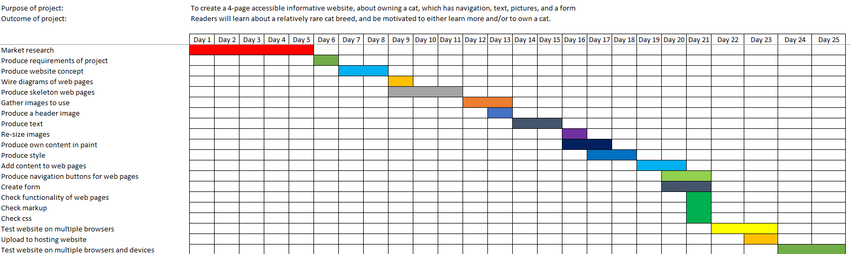

**Kanban**

Kanban is a visual methodology that makes it clearer to see how a project is progressing, taking the form of a to – do list.

**To do**

* Gather images to use
* Produce a header image
* Produce text
* Re-size images
* Produce own content in paint
* Produce style
* Add content to web pages
* Produce navigation buttons for web pages
* Create form
* Check functionality of web pages
* Check markup
* Check css
* Test website on multiple browsers
* Upload to hosting website
* Test website on multiple browsers and devices

**Being done**

* Wire diagrams of web pages
* Produce skeleton web pages

**Finished**

* Produce requirements of project
* Produce website concept
* Market research

**Standup meetings**

Standup/ scrum meetings are short meetings where people involved discuss updates, what they need help with or are going to be working on (i.e. sprinting) next. If a team need more resources it is for the scrum master to find the resource for them